Skills Test Unit 7 Test B

Name: ___________________________________________

Everyday English

1. Complete the sentences (1–5) with the words below. Then match them to the correct responses (A–E) to make dialogues.

mind grateful excuse happy wonder

1. Would you ____________ closing the window? There’s a horrible smell outside. ___
2. Waiter! This pudding tastes awful! I ____________ if you could change it for something else. ___
3. I’m really not very ____________ about my seat. I’m so far back I can’t see a thing! ___
4. I’d be ____________ if you would stop touching things in the shop that you haven’t paid for. ___
5. ____________ me, could you turn down your music? I can’t hear myself think! ___
6. Oh, sorry. I didn’t realize that we weren’t allowed to pick things up.
7. Of course, madam. I’ll bring you the menu and you can choose another dessert free of charge.
8. I’m sorry about that, sir, but the theatre’s full tonight so I can’t move you.
9. Oh, sorry, I didn’t think it was that loud.
10. Sure. But it’ll get hot and stuffy inside now.

Mark: ___ / 5

Listening

1. 🎧 Listen to Becky Sharp’s interview with Dougal Black, the head chef of The Corner Restaurant in London. Complete this sentence.

The two ________ that Becky and Dougal mention are smell and taste.

1. 🎧 Listen again. Circle the correct answers (a–c).
2. Becky says that The Corner Restaurant is
   1. in the centre of town.
   2. hard to find.
   3. on a busy road.
3. Becky describes Dougal as
   1. a good boss to work for.
   2. the boss – but only in the kitchen.
   3. both a chef and an owner.
4. Today Becky has noticed that the restaurant kitchen is
   1. cooking sauces.
   2. baking.
   3. catching mice.
5. Dougal says that when he was a trainee,
   1. he found it easier to differentiate between tastes than can now.
   2. he spent lots of time learning how to notice subtle changes in taste.
   3. he had a good teacher who taught him everything.

Mark: ___ / 10

Reading

The old osprey

The Scottish Wildlife Trust recently announced that a beautiful and unique bird had returned to a nesting site in one of its wildlife reserves in northern Scotland. The bird’s name is Lady and it’s an osprey, which is a type of fishing eagle. Ospreys were hunted to the edge of extinction in Scotland in the early twentieth century, but nowadays, thanks to an enormous conservation programme, there are approximately 200 breeding pairs in the country. Lady is unique, however, because she is over twenty-five years old, which makes her the oldest osprey in Britain. The Trust expressed its surprise that Lady had survived the winter. During the previous breeding season, she had seemed old and ill and they hadn’t expected her to have the strength to complete the long 10,000 km migration to West Africa and back which all ospreys undertake each year.

Like all hunting birds, ospreys have excellent eyesight. Incredibly, they are able to focus in two directions at the same time, which means that they can see both what’s in front of them (with one eye), and what’s to the side (with the other). Their vision is so sharp that they can see things four times more clearly than a human can. In fact, they can identify a fish just below the surface of the water which is invisible to our eyes. Some eagles can scan an area of 500 m2 from a height of 300 m, and spot the movement of a small rabbit.

Osprey expert Roberta Hart told reporters that Lady’s survival was a sure sign that the osprey conservation programme was going well. Indeed, Roberta said that Lady herself had made a significant contribution to its success by laying fifty-eight eggs and rearing forty-eight chicks to adulthood. She agreed, however, that it remained to be seen whether Scotland’s oldest osprey would be able to add to her remarkable record of successful breeding. At her great age, Lady may not be fertile enough to lay more eggs, and even if she is, there is as yet no sign of the whereabouts of the male osprey who has been Lady’s regular partner during the last few breeding seasons. The trust has asked local bird spotters to watch out for the male’s return. However, they are concerned that he may have died during the dangerous and demanding flight north from West Africa.

The Wildlife Trust is rightly proud of having protected ospreys in the wild, and it hasn’t always been easy. They have faced opposition from local fishermen and have had to watch nests around the clock at times in order to ensure that vandals and egg thieves don’t disturb the birds. To celebrate their success, they have published a book about Lady’s life story which you can purchase on their website. It’s a beautiful story about a wonderful bird.

1. Read the text. Circle the correct answers (a–d).
2. What does the opening paragraph say about the number of ospreys in Scotland?
   1. Their numbers are declining in the north of the country.
   2. There are more ospreys now than there were 100 years ago.
   3. There are about 400 ospreys living in Scotland.
   4. They are the most common hunting bird in the country.
3. What is unique about Lady?
   1. She’s survived for an unexpectedly long time.
   2. She’s very beautiful for an osprey.
   3. She’s part of the most successful breeding pair.
   4. She flew all the way to Africa and back.
4. What’s special about an osprey’s eyesight?
   1. It is better than most other hunting birds.
   2. They can only see what’s directly in front of them.
   3. They can focus on small objects from great distances.
   4. Their eyes are twice as sharp as ours.
5. What did Roberta say about Lady?
   1. She has been the best example of conversation in their programme.
   2. She will probably continue to breed successfully this year.
   3. She is looking out for a new male bird to breed with.
   4. She has brought up a lot of offspring successfully.
6. What problems have the Wildlife Trust had in their work to conserve ospreys?
   1. Local fishermen have stolen osprey eggs.
   2. Most of the local population have opposed their work.
   3. They have sometimes had to keep a close eye on nesting sites.
   4. Vandals have regularly taken eggs from the ospreys’ nests.

Mark: ___ / 10

Writing

1. Study the information in the pie chart. Then write a report for the school management team.

Warwick School’s favourite 11 o’clock snacks

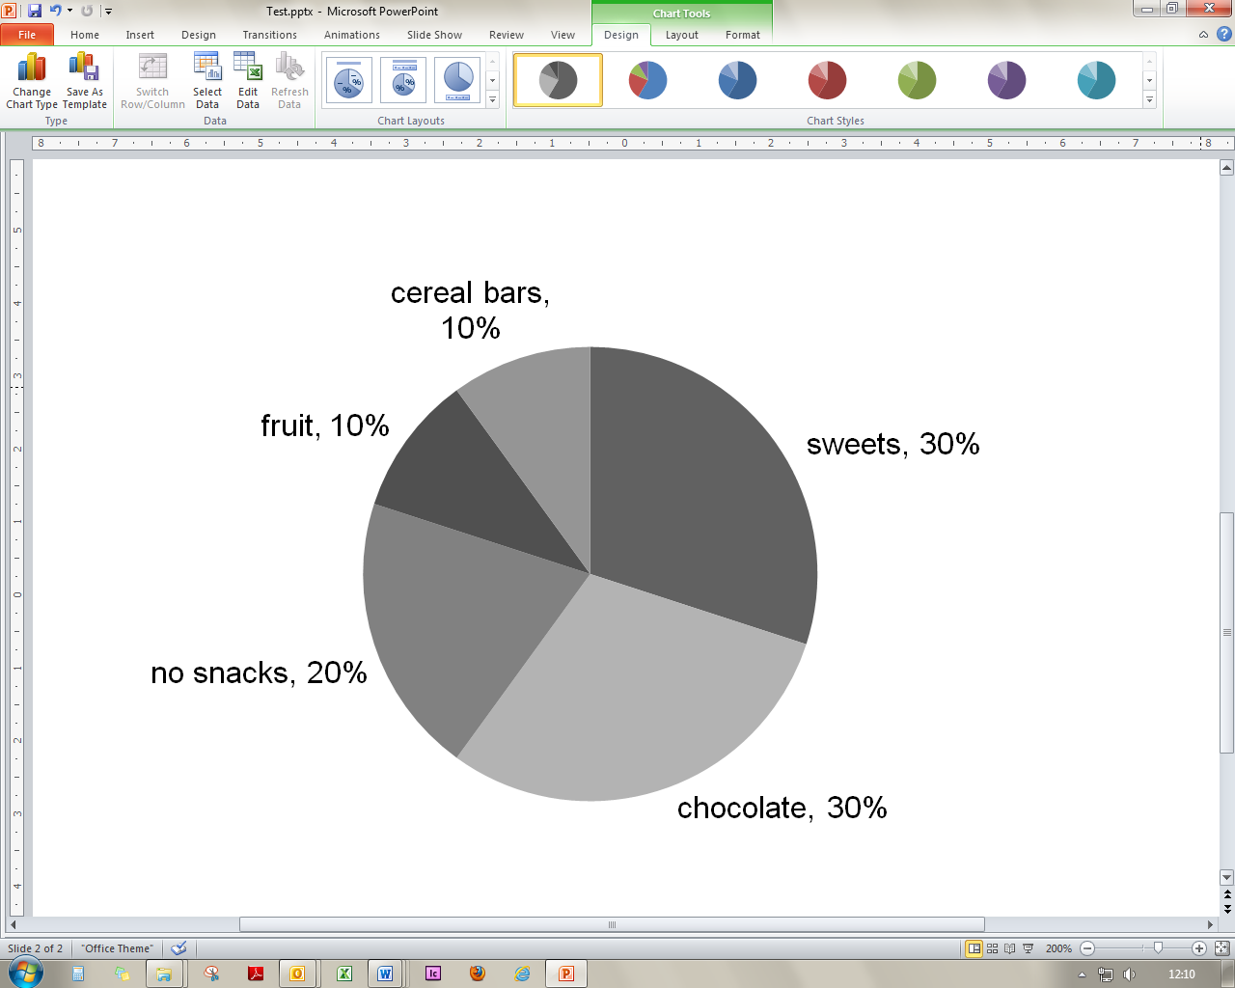

**Write your report. Use the plan to help you.**

**Paragraph 1:** Explain the purpose of the survey.

**Paragraph 2:** Analyse the results of the survey.

**Paragraph 3:** Write the report’s conclusion and make a recommendation.

Mark: ___ / 15

TOTAL MARKS: ___ / 40

Challenge!

1. Complete the text with the correct form of the words in brackets.

Are bats blind?

Actually, bats aren’t blind – but their eyes 1____________ (not develop) as well as ours. However, since they often live in complete 2____________ (dark), they don’t need good eyesight. If you 3____________ (be) a bat, your way of seeing the world would be 4____________ (surprise) different from that of most mammals. Over millions of years, life in the dark has caused bats to develop echolocation to build up a picture of their environment. High-pitched noises 5____________ (make) by bats when they are flying. The bats then collect the information which is created by their own sounds and use this information to 6____________ (location) objects on their journey. Their 7____________ (react) depend on the situation they are in. A zoologist told me that he 8____________ (see) horseshoe bats which could catch moths in the dark if they 9____________ (fly) past them. They had the 10____________ (able) to sense the delicate movement of an object – in this case a moth’s wing – by using echolocation.